Table 1. Operating conditions for the baseline case of the NIST benchmark database.

Fuel | Methanol
Fuel Flow Rate | 3.0 kg h⁻¹
Fuel Temperature | Ambient
Equivalence Ratio | 0.3
Air Flow Rate | 56.7 m³ h⁻¹
Air Temperature | Ambient
Vane Angle | 50º
Swirl Number | 0.58
Flame Standoff Distance | ~ 5 mm
Chamber Pressure | Ambient

Table 2. Reactor wall temperatures.

Thermocouple | Height  (mm) | Mean  Temperature  (ºC)
TC #1 | 99 | 93
TC #2 | 165 | 93
TC #3 | 231 | 95
TC #4 | 297 | 99
TC #5 | 429 | 103
TC #6 | 561 | 112
TC #7 | 693 | 114
TC #8 | 826 | 121
TC #9 | 958 | 133
TC #10 | 1090 | 136

Table 3. Exit gas temperatures.

Radial  Coordinate, ρ  (mm) | Polar  Angle, φ  (deg) | Mean  Temperature  (ºC)
0 | - | 244
44.5 | 0 | 265
88.9 | 0 | 282
133.4 | 0 | 288
177.8 | 0 | 266
44.5 | 90 | 251
88.9 | 90 | 258
133.4 | 90 | 271
177.8 | 90 | 277
44.5 | 180 | 221
88.9 | 180 | 207
133.4 | 180 | 182
177.8 | 180 | 160

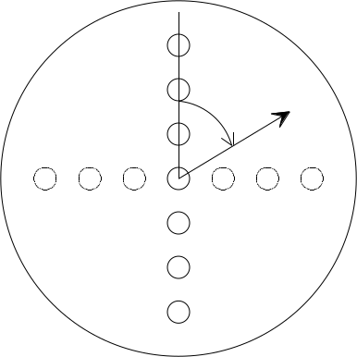
φ
ρ
End Plate (see schematic of NIST facility).

